
UNIVERSITY OF ENGINEERING AND TECHNOLOGY PESHAWAR, JALOZAI CAMPUS
Lab 13: Open-Ended
Lab Title: EE-271 “Machine Learning Lab”
Note: Using the internet is helpful for finding relevant code and modifying it to solve the problem at hand.
Date: Wednesday, May 20, 2026 Time: 120 min

Problem Statement
Design a model to forecast in the CityLearn challenge.
Description:
CityLearn is an open-source Farama Foundation Gymnasium environment for implementing Multi-Agent Reinforcement Learning (MARL) to coordinate building energy and demand response in cities. A major challenge for RL in demand response is comparing algorithm performance. Thus, CityLearn facilitates and standardizes the evaluation of RL agents, enabling easy comparison across algorithms.
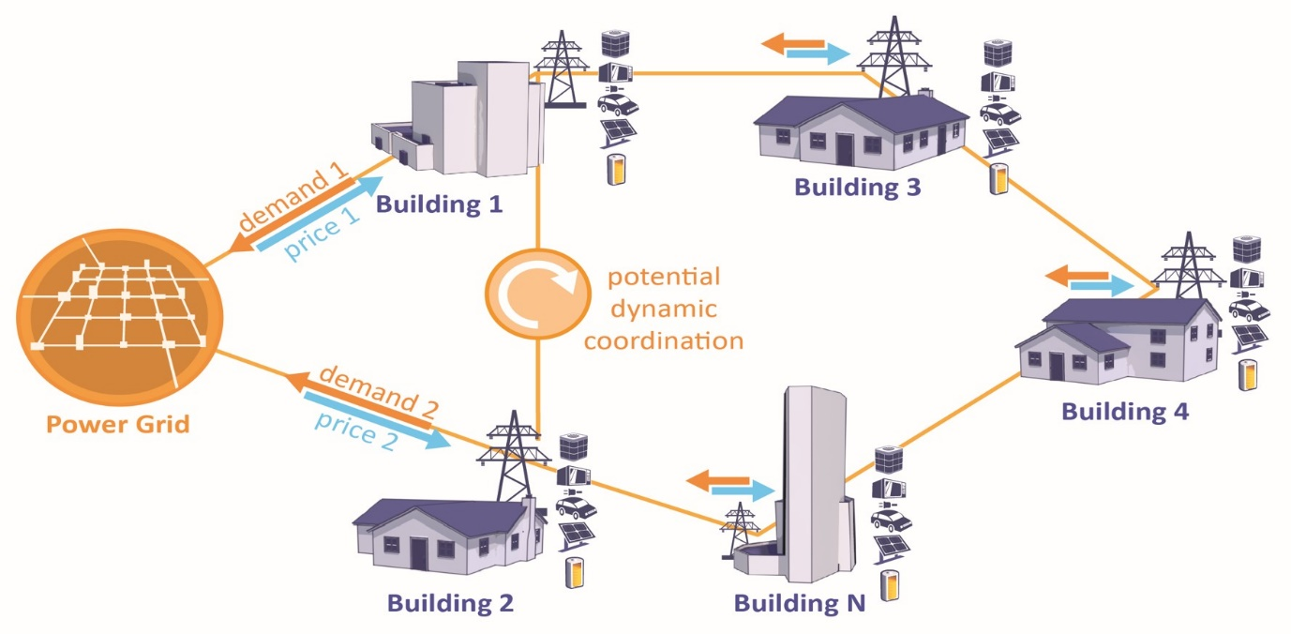
Districts and cities experience periods of high electricity demand, which raises electricity prices and the overall cost of power distribution networks. Flattening, smoothing, and reducing the overall curve of electrical demand helps reduce the operational and capital costs of electricity generation, transmission, and distribution networks. CityLearn enables the easy implementation of reinforcement learning agents in single- or multi-agent settings to reshape the aggregated curve of electrical demand by controlling active energy storage for load shifting and heat pump or electric heater power for load shedding.

Data:
You can get the data from the following link.
GitHub - intelligent-environments-lab/CityLearn: Official reinforcement learning environment for demand response and load shaping
Related Course Learning Outcome (CLO):

Rubrics | CLO
Data Handling | 1
Model development | 2

Rubrics:
Rubrics | Good (100 %) | Average (75%) | Unsatisfactory (50%)
Data Handling | Data Collection and Import, Data Cleaning, Data Exploration and Visualization, Feature Engineering and Selection, Data Normalization | Data Collection and Import, Data Cleaning, Data Exploration and Visualization | Data Collection and Import
Model development | Algorithm Choice and Justification, Hyperparameter chosen, Model Training, Model Evaluation | Algorithm Choice and Justification, Hyperparameter chosen, Model Training, | Algorithm Choice and Justification

Reference:
- CityLearn — CityLearn 2.3.0 documentation

